**Large Scale Optimization**

SOLVING A NETWORK DESIGN PROBLEM USING BENDERS DECOMPOSITION

Problem to solve:

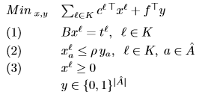

1. Solve the problem directly, i.e., without using Benders decomposition and report the resulting solution:
   1. Objective function value in its tow components:
      1. investment costs,
      2. exploitation costs.
   2. List of candidate links a ∈ A which will be included in the solution of the problem, i.e., links a ∈ A for which ya = 1.

Images are taken from AMPL console. First, we show how to solve the problem in AMPL.

**Model benderspart0.mod;**

**Data bendersOGE.dat;**

**Options solve cplexamp;**

**Solve;**

list of displays:

Display y (binary variables related with Ahat arcs)

The results obtained are:

**OPTIMAL SOLUTION**

Recorte de pantalla

This are the binary variables that have been activated in the problem. The final optimal solution was 77717.2 (including investment and exploitation costs).

Binary variables for Ahat. This output show which arcs will be activated ([10,5], [14,13], [22,23]).

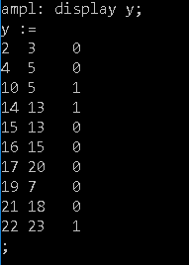

Invesment costs

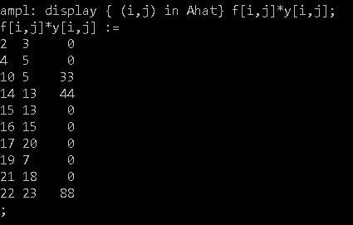

Sum of investment costs:

Recorte de pantalla

Exploitation costs:

$$\sum_{l}^{O}{\sum_{i,j}^{AA}{c\left[i,j,l\right]*xl\left[i,j,l\right]=77552,2}}$$

O are the initial Nodes (3,11) and AA are all the arcs (union of A and Ahat).

Recorte de pantalla

Master Problem:

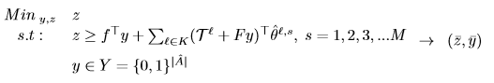

Subproblem:

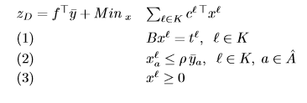

1. Solve the problem using Benders decomposition. Once the algorithm has been satisfactorily implemented, report the problem’s solution starting from two diﬀerent initial solutions for the binary decision variables y. These two point are: a) ya = 0, ∀a ∈ A, b) ya = 1, ∀a ∈ A.

In both cases report always a summary of the iterations carried out by the algorithm by means of a table or list in which, for each iteration the following appears reported:

* 1. Objective function’s value ¯ z of Master Problem.
  2. Objective function’s value for the Subproblem zD resulting from decision variables y, as well as the investment and exploitation costs.

Finally report what led the algorithm to stop and the ﬁnal solution in the form of the subset of links within the candidates in a ∈ ˆ A that have been included and excluded. Report also the value of the ﬂows on the network links for the ﬁnal network’s conﬁguration.

It is required to present the AMPL’s code developed in the implementation and a report, of up to 12 pages in length, answering properly the previous questions.

The stop Criteria is:

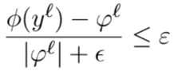

But we add the investment costs to sub-problem and compute the GAP to ensure that the value of subproblem is smaller than the value of the master problem.

Now we show the values of the master problem, the subproblem, the investment and exploitation costs.

First we start with y equal to 0.

|  |  |
| --- | --- |
| **Benders Decomposition. ITERATIONS 9** | |
| ITERATION 1 | |
| ZD: 83746.4 | ZMP: -95.128,8 |
| Exploitation costs: 83746.4 | Investment costs: 0 |
| ITERATION 2 | |
| ZD: 77552.2 | ZMP: 77585.2 |
| Exploitation costs: 77552.2 | Investment costs: 264 |
| ITERATION 3 | |
| ZD: 82426.4 | ZMP: 77596.2 |
| Exploitation costs: 82426.4 | Investment costs: 33 |
| ITERATION 4 | |
| ZD: 81346.4 | ZMP: 77629.2 |
| Exploitation costs: 81346.4 | Investment costs: 44 |
| ITERATION 5 | |
| ZD: 80026.4 | ZMP: 77640.2 |
| Exploitation costs: 80026.4 | Investment costs: 77 |
| ITERATION 6 | |
| ZD: 81272.2 | ZMP: 77673.2 |
| Exploitation costs: 81272.2 | Investment costs: 88 |
| ITERATION 7 | |
| ZD: 79952.2 | ZMP: 77684.2 |
| Exploitation costs: 79952.2 | Investment costs: 121 |
| ITERATION 8 | |
| ZD: 78872.2 | ZMP: 77717.2 |
| Exploitation costs: 78872.2 | Investment costs: 132 |
| ITERATION 9 | |
| ZD: 77552.2 | ZMP: 77717.2 |
| Exploitation costs: 77552.2 | Investment costs: 165 |
| Final GAP: 0 | |

The algorithm stops with a GAP of zero and the values obtained are equal to the value of the objective function in the exercise 1.

**Graphical evaluation of Iterations**

The next graph shows the evolution of MASTER and Subproblem, in subproblem we add the investment costs (R Code).

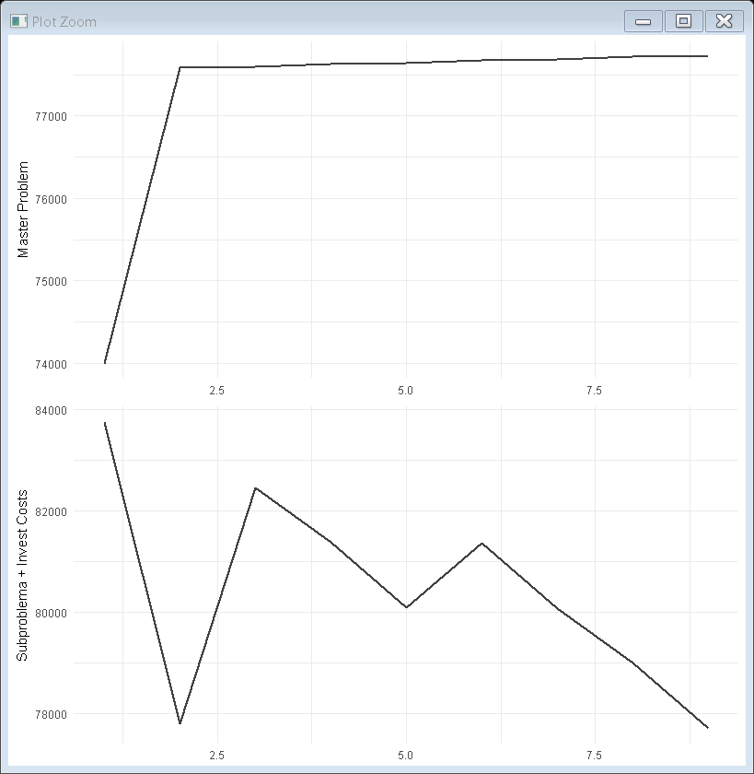

Figure 1 Master and Subproblem

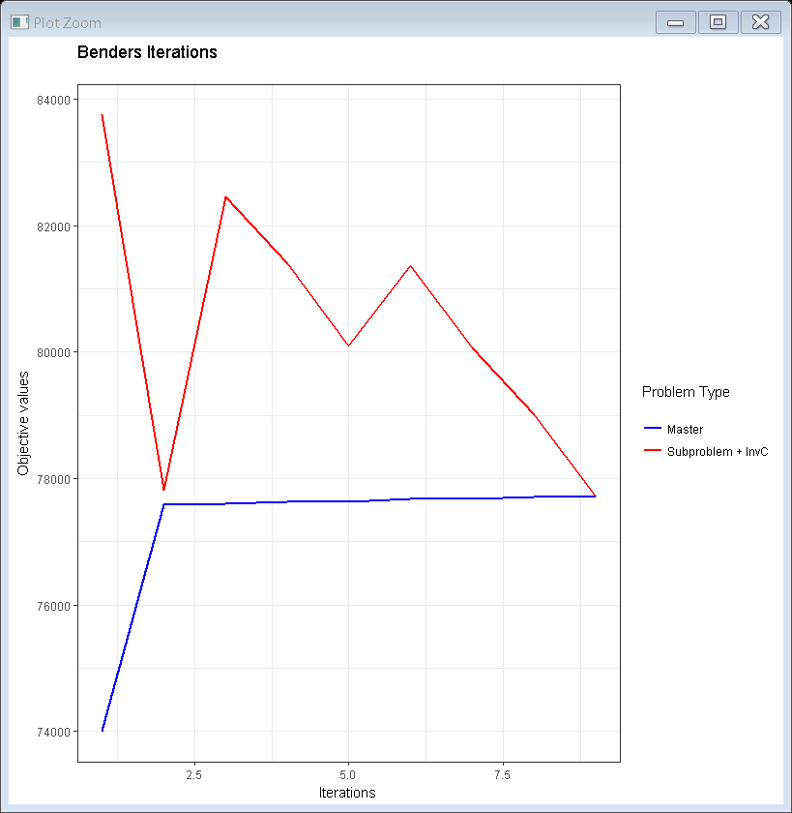

Figure 2 Benders Master and Subproblem

In both graphs the value of Master starts at 74.000. The reason is because with a high range the quality of image was worse, and it seems like in the second iteration the problem converges.

The real value of the initial ZMP was -95.128.

Now we start with y equal to 1.

|  |  |
| --- | --- |
| **Benders Decomposition. ITERATIONS 9** | |
| ITERATION 1 | |
| ZD: 83746.4 | ZMP: -95.128,8 |
| Exploitation costs: 83746.4 | Investment costs: 561 |
| ITERATION 2 | |
| ZD: 77552.2 | ZMP: 77585.2 |
| Exploitation costs: 77552.2 | Investment costs: 264 |
| ITERATION 3 | |
| ZD: 82426.4 | ZMP: 77596.2 |
| Exploitation costs: 82426.4 | Investment costs: 33 |
| ITERATION 4 | |
| ZD: 81346.4 | ZMP: 77629.2 |
| Exploitation costs: 81346.4 | Investment costs: 44 |
| ITERATION 5 | |
| ZD: 80026.4 | ZMP: 77640.2 |
| Exploitation costs: 80026.4 | Investment costs: 77 |
| ITERATION 6 | |
| ZD: 81272.2 | ZMP: 77673.2 |
| Exploitation costs: 81272.2 | Investment costs: 88 |
| ITERATION 7 | |
| ZD: 79952.2 | ZMP: 77684.2 |
| Exploitation costs: 79952.2 | Investment costs: 121 |
| ITERATION 8 | |
| ZD: 78872.2 | ZMP: 77717.2 |
| Exploitation costs: 78872.2 | Investment costs: 132 |
| ITERATION 9 | |
| ZD: 77552.2 | ZMP: 77717.2 |
| Exploitation costs: 77552.2 | Investment costs: 165 |
| Final GAP: 0 | |

The algorithm stops with a GAP of zero and the values obtained are equal to the value of the objective function in the exercise 1. We can see that putting the initial solution to 1 we make the initial investment cost high.

The variables of the problem can be separated in two parts in such a way that, when fixing the value of one part the problem associated with the remaining ones has a straightforward solution.

If the inner minimization problem (Sub) is infeasible for some x∈ X , then there must exist a λ ≥ 0 verifying WTλ ≤ c for which λT(b −Tx) > 0 , so that a ray v = λ representing an improving direction in the dual polyhedron can be defined. By contrast, if the inner minimization problem is feasible for a given x∈ X , then λT (b −Tx) ≤ 0, for whatever λ ≥ 0 verifying WTλ ≤ c, and u = λ defines an extreme point of the dual polyhedron.

In our case the compact form allows to avoid unbounded problems and the first part it’s not necessary.

To **resume** the idea of Benders Decomposition, in each iteration we solve the subproblem and evaluate the GAP with Master Problem. In each iteration the value of master problem increases but the value of subproblem (related to exploitation costs) can increase or decrease in each iteration. At the end the values of both problems converge in a value of the objective function equal to 77717.2.

Appendix

Values of y for each ITERATION of Benders algorithm starting with **y = 0**.

|  |  |
| --- | --- |
| Iter 1 | Iter 2 |
| y :=  2 3 0  4 5 0  10 5 0  14 13 0  15 13 0  16 15 0  17 20 0  19 7 0  21 18 0  22 23 0 | y :=  2 3 0  4 5 1  10 5 1  14 13 1  15 13 0  16 15 1  17 20 0  19 7 0  21 18 0  22 23 1 |
| Iter 3 | Iter 4 |
| y :=  2 3 0  4 5 0  10 5 1  14 13 0  15 13 0  16 15 0  17 20 0  19 7 0  21 18 0  22 23 0 | y :=  2 3 0  4 5 0  10 5 0  14 13 1  15 13 0  16 15 0  17 20 0  19 7 0  21 18 0  22 23 0 |
| Iter 5 | Iter 6 |
| y :=  2 3 0  4 5 0  10 5 1  14 13 1  15 13 0  16 15 0  17 20 0  19 7 0  21 18 0  22 23 0 | y :=  2 3 0  4 5 0  10 5 0  14 13 0  15 13 0  16 15 0  17 20 0  19 7 0  21 18 0  22 23 1 |
| Iter 7 | Iter 8 |
| y :=  2 3 0  4 5 0  10 5 1  14 13 0  15 13 0  16 15 0  17 20 0  19 7 0  21 18 0  22 23 1 | y :=  2 3 0  4 5 0  10 5 0  14 13 1  15 13 0  16 15 0  17 20 0  19 7 0  21 18 0  22 23 1 |
| Iter 9 (Final Iteration) | |
| y :=  2 3 0  4 5 0  10 5 1  14 13 1  15 13 0  16 15 0  17 20 0  19 7 0  21 18 0  22 23 1 | |

Now we start with **y = 1**.

|  |  |
| --- | --- |
| Iter 1 | Iter 2 |
| y :=  2 3 1  4 5 1  10 5 1  14 13 1  15 13 1  16 15 1  17 20 1  19 7 1  21 18 1  22 23 1 | y :=  2 3 0  4 5 1  10 5 1  14 13 1  15 13 0  16 15 1  17 20 0  19 7 0  21 18 0  22 23 1 |
| Iter 3 | Iter 4 |
| y :=  2 3 0  4 5 0  10 5 1  14 13 0  15 13 0  16 15 0  17 20 0  19 7 0  21 18 0  22 23 0 | y :=  2 3 0  4 5 0  10 5 0  14 13 1  15 13 0  16 15 0  17 20 0  19 7 0  21 18 0  22 23 0 |
| Iter 5 | Iter 6 |
| y :=  2 3 0  4 5 0  10 5 1  14 13 1  15 13 0  16 15 0  17 20 0  19 7 0  21 18 0  22 23 0 | y :=  2 3 0  4 5 0  10 5 0  14 13 0  15 13 0  16 15 0  17 20 0  19 7 0  21 18 0  22 23 1 |
| Iter 7 | Iter 8 |
| y :=  2 3 0  4 5 0  10 5 1  14 13 0  15 13 0  16 15 0  17 20 0  19 7 0  21 18 0  22 23 1 | y :=  2 3 0  4 5 0  10 5 0  14 13 1  15 13 0  16 15 0  17 20 0  19 7 0  21 18 0  22 23 1 |
| Iter 9 (Final Iteration) | |
| y :=  2 3 0  4 5 0  10 5 1  14 13 1  15 13 0  16 15 0  17 20 0  19 7 0  21 18 0  22 23 1 | |